**Overview:**

The goal is to create a website that serves as a way for users to rank different ‌entertainment and build a community for like-minded people to discuss and grow together. The website will rate anime, music, video games, books, and other forms of entertainment. The vision is to create a uniform utopia where every entertainment consumer can co-exist together.

**Competition**

An example of what we envision is what My Anime List (Mal) has done. My Anime List is a website where users can list every anime or manga they have watched or read and rank them. My anime list also serves as a discussion page where we can see the total ranking of every anime on the site, discuss specific anime and form a community with people who have the same taste as them.

[My Anime List](https://myanimelist.net/)

We plan on doing something similar to this but on a grander scale. This will set us apart from MAL because we plan on incorporating anime, music, gaming, and even movies into our catalog.

**Usage or Benefit:**

The primary thing that sets us apart from MAL is our website’s scope. We want our website to be synonymous with all online entertainment rankings. Just like Rotten Tomatoes is synonymous with the cinema-going experience, we want to be that but for all forms of entertainment. We plan to create a better user experience than MAL, our only competitor. As of right now, there isn’t a massive demand for our service, but that doesn't mean it can’t be helpful. There’s a void right now, and we have the perfect solution to fill that void.

**Users:**

We plan on targeting every age group and assimilating them into our universe. A 15-year-old male who loves power rangers can log into the website, make an account and join servers discussing his favorite series in the power rangers universe. We can say the same for a 65-year-old user who loves James Patterson, and his book series; they also can use the website and find like-minded users.

The purpose of creating a multi-layered website with different entertainment is that it will also be useful in introducing others into certain forms of media. For example, let's bring back our 65-year-old user named Jocelyne, who signed up for the website to discuss James Patterson novels and those novels alone. But because others are also using this website to discuss anime and video games, it can introduce Jocelyne to anime because she saw it on the front page or on a discussion forum about it.

**Discussion Forum:**

After a user has created an account and made their ranking of shows and music, they can join the discussion servers of said show or music. They can always access it anytime and discuss it. We will divide this discussion forum into subsections like a server to discuss specific episodes, characters, scenes, and the rest.

**Messaging:**

Another feature we would add to the website to create a community is messaging other users. For instance, Josh is a user who loves Black Clover, and he has nothing to watch right now because the anime is on hiatus. He needs something to replace that void, and he could privately message another user in the Black Clover server if there’s a show similar to it.

Messaging other users wouldn’t be tied down to just among server users. Messaging can be done with any user who has their profile public.

**Database:**

The database part of the website will be done using JSON and MySQL to store our own data. These data are public dater or user-generated data that will be completed by the users to rank or discuss certain topics. The use of JSON and PHP data united by the user is stored and kept on our backend so they can always retrieve them whenever they log back in.

**Issues:**

An issue that might occur if users make their profile public is that it might lead to bullying and harassment by some bad apples in the community. Even though toxic behaviors can’t be controlled, we can prevent this by having users rank each other. If a user has a score beyond a certain level, we might ban them from using some features like joining a server or sending messages to users they aren’t friends with. This punishment will be temporary, but we will ban them off the platform if the behavior continues. Another way we can prevent harassment in the community is to allow users to report rotten eggs. Specific users will control every server, like moderators similar to Discord. Said moderator has power over the server and can ban or limit a user from accessing features in the server.

**Growth:**

The perfect way to grow our user base is through word of mouth. We can increase the website by first introducing the students of RPI to using the website and telling us their opinion on it. RPI is the perfect place to get users of every age and every taste. We can launch the website by introducing it to the various clubs in the school and asking them to beta test it.

Another way to grow the ITWS website is by having users share their rankings on other social media. Spotify is an excellent example of this. At the end of every year, Spotify ranks every user's favorite music and podcast, allowing users to share this list with the public on social media. Since the ranking is personal and user-generated, users can post their specific orders to other followers on other social media. By doing this, users on Twitter and Facebook who aren’t users of our website can make accounts.

**Music:**

We decided to focus on the music side of things for the final part of the website. Users can make an account and log in and discuss music and the lyrics that mean something to them. This will serve as a bridge of connection between users of different languages, cultures, and understanding of different music genres. Take Hip-hop, for example, hip-hop is rooted in a lot of subliminal messages, stories, and metaphors that date back years since its inception. This creates huge daunting tasks for new listeners of the genre because they are unable to properly understand the messages that are told by some artists in their songs. This is where our website comes in, users are able to log into the website, and have discussions with other users. They are now able to learn from other users as well as teach other users what they think a lyric or a song might be in general. Or they might have a personalized meaning to a song and share it with other users.

The initial proposal was to create an anime-centric website but we landed on the music side and made a website that will be tailored to bridging the cultural gap and differences between music lovers all over the world.

Users can learn about what makes their favorite artist or song special and have educated discussions with other users on the site

**Website Layout**

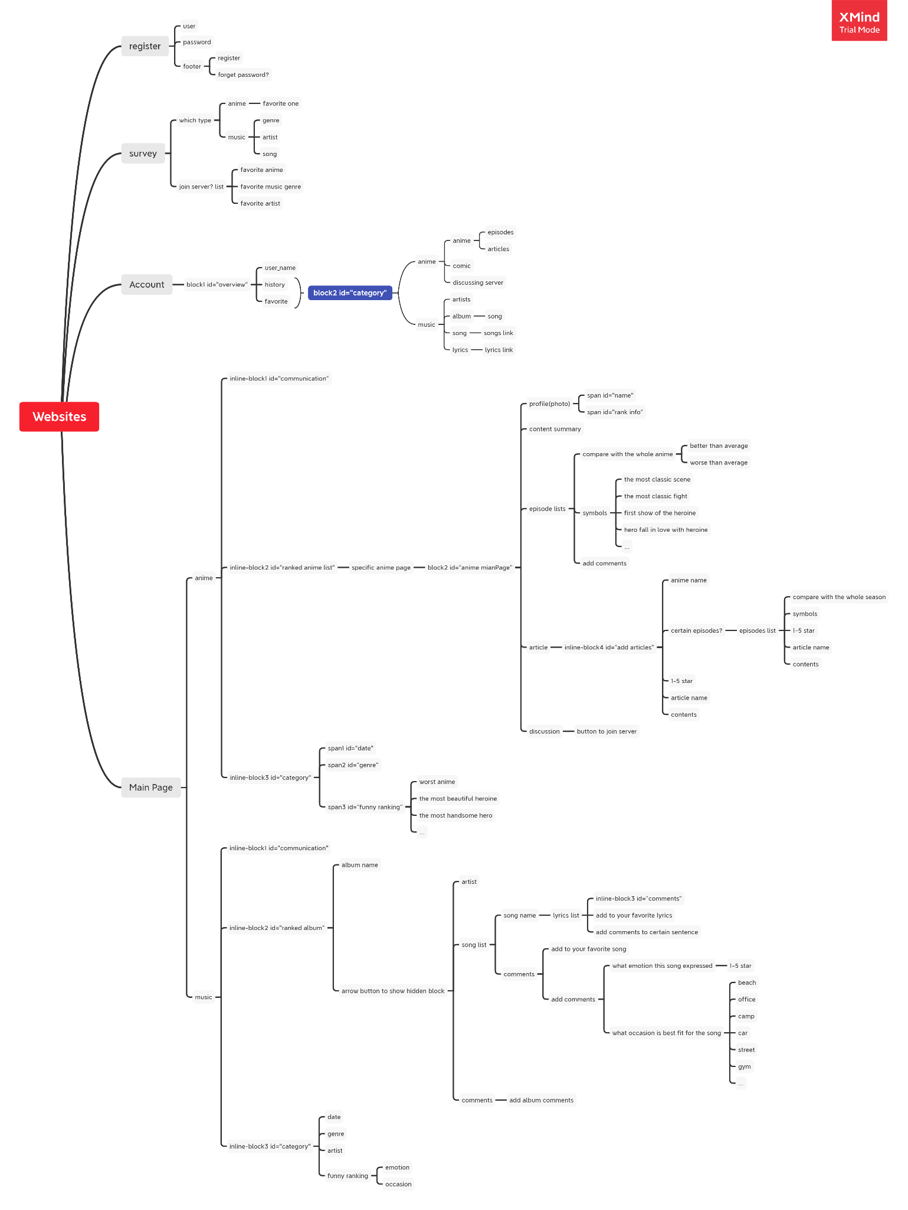

Term Project: Team Plan

* The project concept was a joint effort we combined both our ideas.
* Project Proposal → Oluwapamilerin amuda
* Website layout → Kerui Wu
* Lo-fi Mockup → Kerui Wu
* HTML and CSS → Oluwapamilerin Amuda
* Database → Oluwapamilerin amuda
* PHP → Kerui Wu
* Javascript → Kerui Wu
* Instructions → Kerui Wu
* Lyrics/ artist research → Oluwapamilerin Amuda
* Power point → Oluwapamilerin Amuda
* Ranking system → Kerui Wu
* Landing/ login page → Oluwapamilerin Amuda
* Lyrics page → Kerui Wu
* Comment page/system → Kerui Wu